Welcome to the Janet Videoconferencing Booking Service

These notes will help you to understand the Videoconferencing Booking service. If at any time you have questions or queries related to the booking service, you can contact our Support Centre on Tel: 0131 650 4933.

Remember to add the booking service website address to your bookmarks:
URL www.ja.net/bookvc

Log in screen.

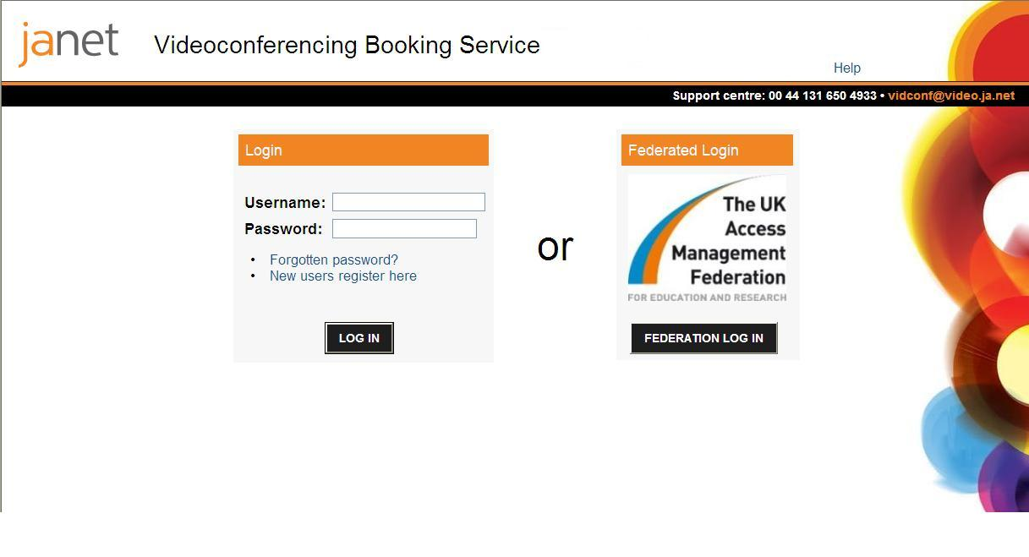

Logging in

If you are an existing user you can log in using your username and password or via your federated login details.
If you would like to know more about Federated login : please visit https://community.ja.net/library/janet-website-how/institutional-login

If you are a new user you will need to register in order to use the Janet Videoconferencing service.

Home page
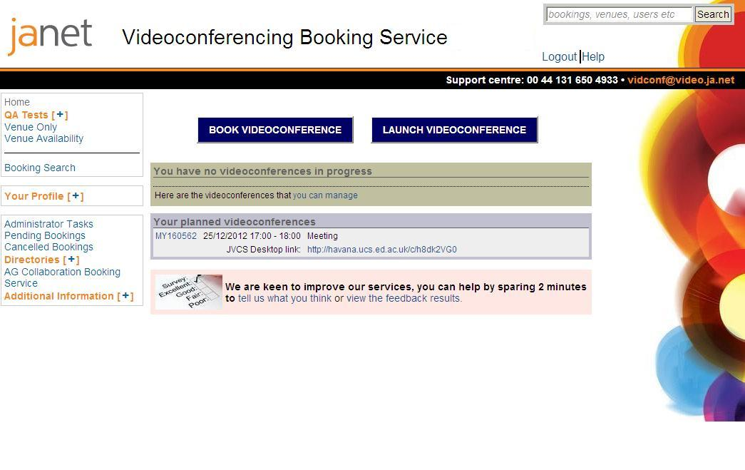

We have introduced two new buttons on the homepage to make it clearer for users.
Clicking on Book videoconference or Launch videoconference will enable you to carry out one of these tasks.

Step 1 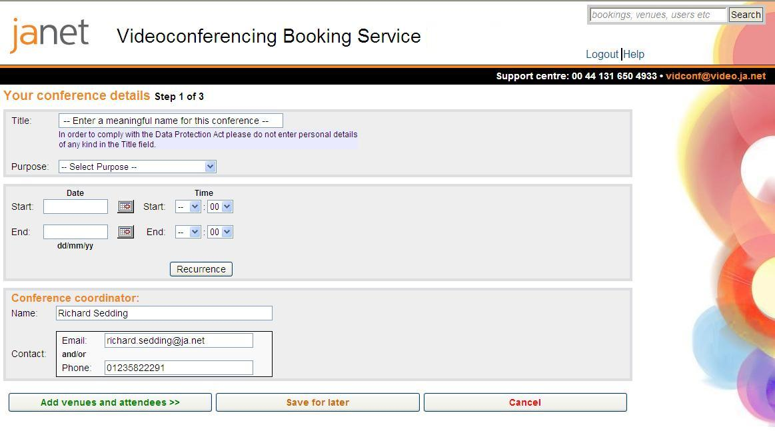

Provide your conference with a name (avoid personal names and details) and then you can select the purpose of your conference. If you click in the start date field, this will populate with today’s date.
At the bottom of the page you will see a new feature. These are arranged in a traffic light format to aid navigation.

Step2 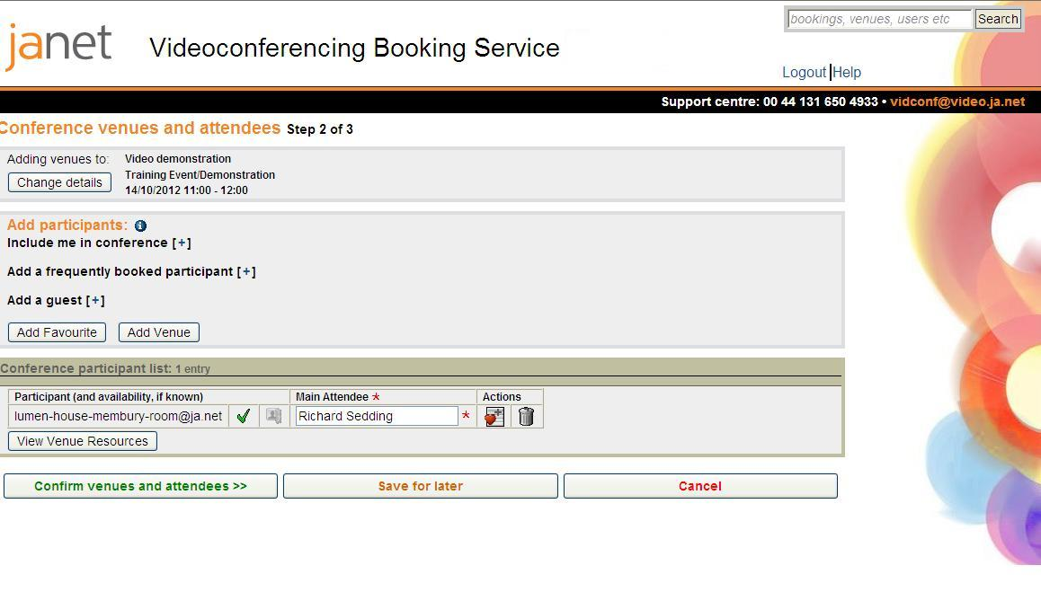

In Step 2 you are required to add participants. You can now to include yourself in the conference by your home room venue, a Desktop PC, or by Telephone. In the example above you can see that we have added Richard at his home venue at Janet.

The expandable lists are designed for ease of use, to make the screen layout less ‘busy’ than before.
Under the frequently booked participant expandable list you can now add room venues, desktop participants or phone users. Guests from outside the Janet community (IP,ISDN,SIP, Desktop,Telephone) can be selected from expandable lists.
If your videoconference includes any IP guest participants, you will need to enter a name, their IP number and a valid email address. The format is the same for the other guest types, with no changes from the existing system.

Step3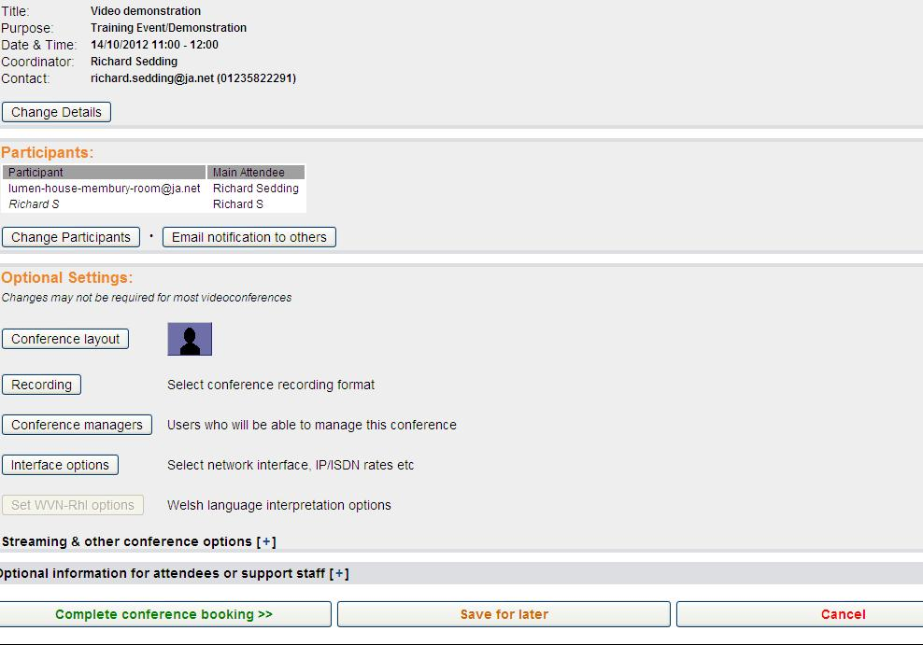

In Step 3, you can request that participants are sent email notification via a button and manage the conference.
At the bottom of the page there is an expandable list Streaming and other conference options which includes Streaming, HD, No MCU to simplify the selection process.

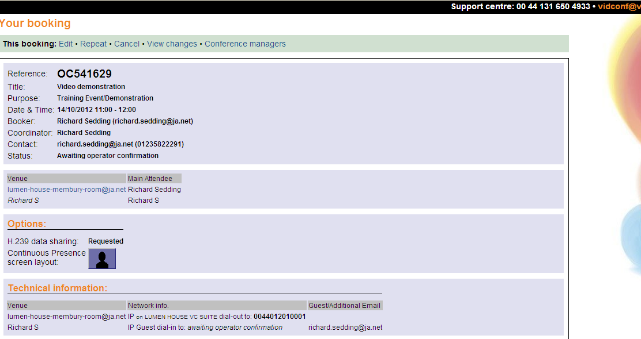

Booking confirmation page.

Once you have booked your conference, you will receive a booking confirmation by email which includes all the details that you have selected.

Once your conference has been completed you will receive a booking completed note with a link to provide feedback on your conference.



